Lesson 7 – Over-Privileged Function
A Lambda compromise becomes much worse because the function role has more AWS permissions than it actually needs, so the attacker can pivot from one function into unrelated backend data.

Goal and Vulnerability Summary
The goal of this lesson was to examine whether the Lambda function DVSA-SEND-RECEIPT-EMAIL was running with more AWS permissions than required for its intended task. In this case, the function was supposed to process receipt-related operations, but its execution role granted broader access than necessary. In addition, the function could expose sensitive runtime information through logging. This combination increases the blast radius of the vulnerability because if the function is abused, the attacker may gain access to unrelated backend resources, as demonstrated in this project through stolen temporary credentials reused to enumerate backend Lambda functions.
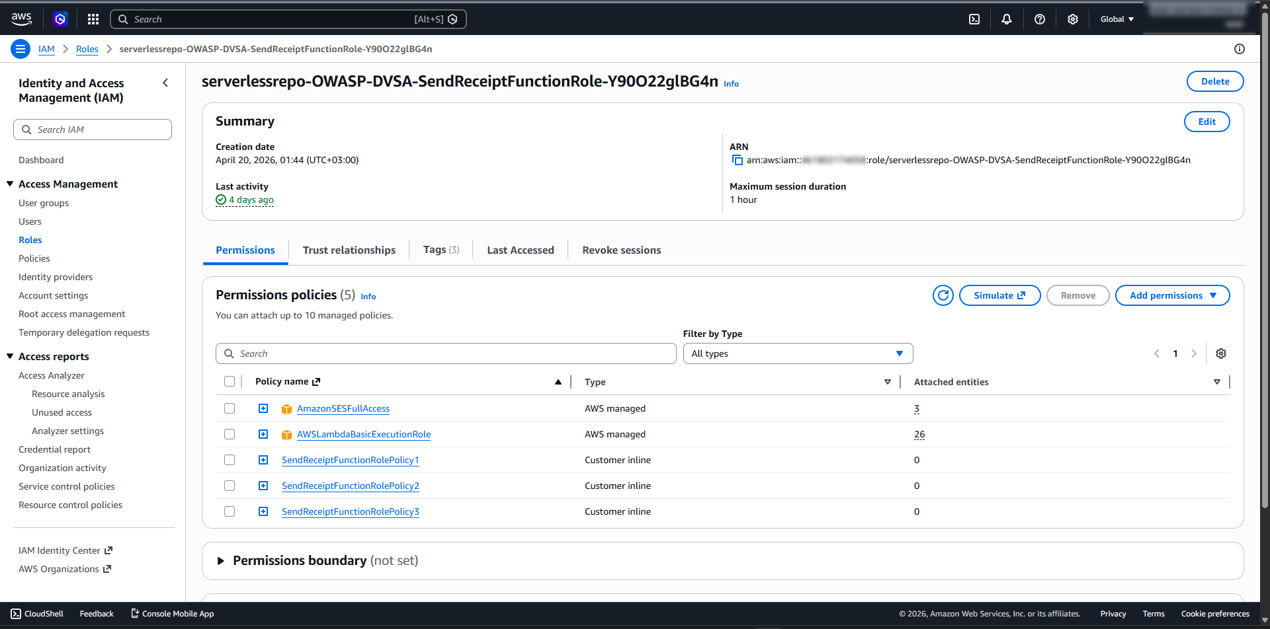
Figure 1: Screenshot #1 - Execution Role Policies

Why This Works / Root Cause
The vulnerability exists because the Lambda execution role violates the principle of least privilege. In particular, the role included unnecessary DynamoDB permissions that were not required for simple receipt-email processing. The issue became more dangerous when environment variables were printed into CloudWatch logs, exposing temporary AWS credentials associated with the function. As a result, a flaw in one function could potentially lead to broader AWS access than intended.
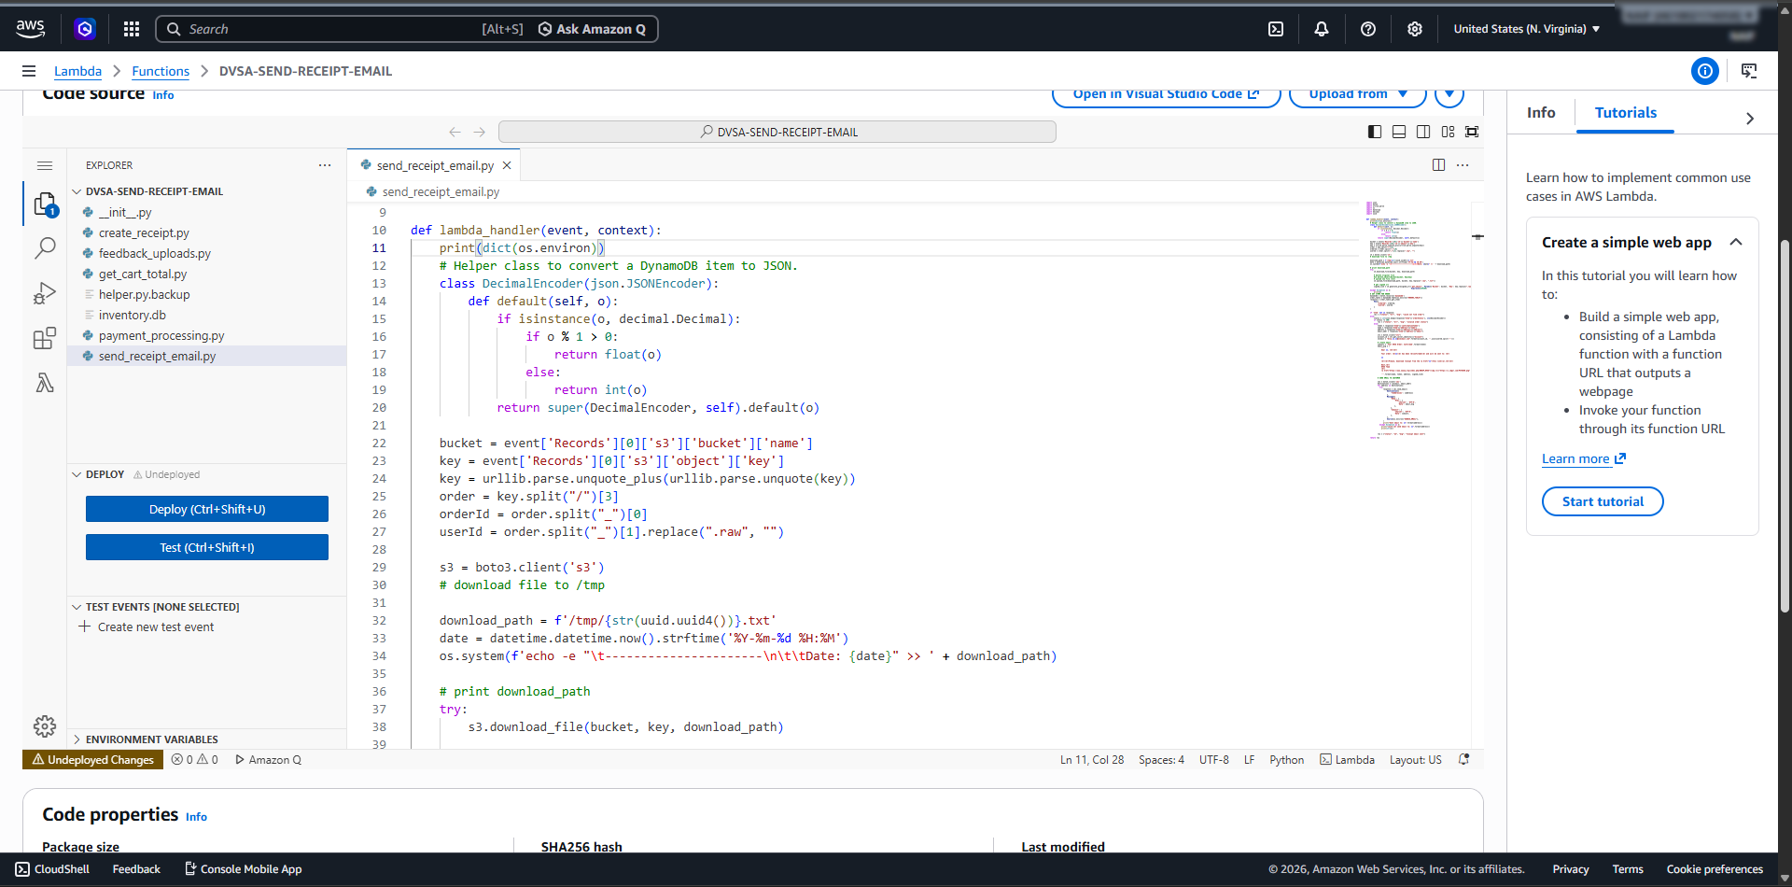
Figure 2: Screenshot #2 - Leaking Credentials Code

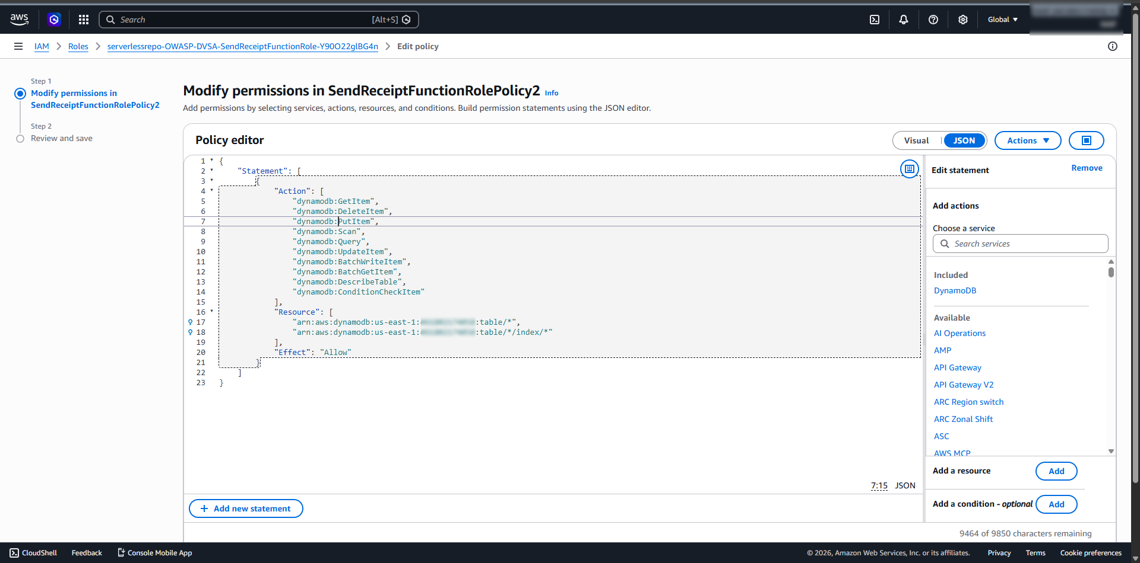
Figure 3: Screenshot #5 - Overbroad Policy2 Before Fix

Environment and Setup
DVSA was deployed in the us-east-1 region in a controlled non-production AWS account. Two test users were created in the application and sample orders were placed to generate normal application data. The vulnerable function used in this lesson was DVSA-SEND-RECEIPT-EMAIL, and its trigger path involved the receipts S3 bucket. A controlled S3 object upload was used to invoke the function and observe its behavior through CloudWatch logs.
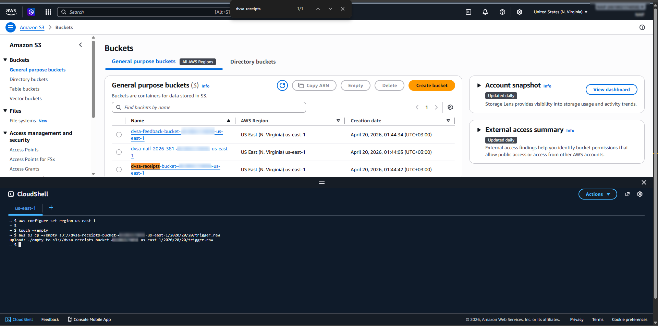
Figure 4: Screenshot #3 - S3 Trigger

Reproduction Steps
First, the execution role attached to the function was inspected and its policies were reviewed. Then, the function code in send_receipt_email.py was modified to print environment variables using print(dict(os.environ)). After deploying the modified function, a dummy file was uploaded to the receipts bucket in order to trigger the Lambda execution. CloudWatch logs were then inspected, and the runtime environment output showed sensitive values such as temporary AWS credentials. This confirmed that the function leaked sensitive information through logs. In addition, inspection of the role policies showed that the function had broader DynamoDB permissions than needed, which made the weakness more severe.

Evidence and Proof
The proof for this lesson came from multiple sources. First, the execution role attached to DVSA-SEND-RECEIPT-EMAIL showed that the function had several policies, including a policy with overly broad DynamoDB permissions. Second, the modified send_receipt_email.py code printed environment variables to CloudWatch logs. After triggering the function through the receipts S3 bucket, the CloudWatch output showed sensitive runtime values, including temporary AWS credentials such as AWS_ACCESS_KEY_ID, AWS_SECRET_ACCESS_KEY, and AWS_SESSION_TOKEN. This demonstrated that the function leaked sensitive information through logs. The role inspection and policy contents also showed that the function had broader DynamoDB access than required for receipt processing, which increased the severity of the issue.

While the original analysis began with the DVSA-SEND-RECEIPT-EMAIL function and its overbroad permissions, the full-chain credential exfiltration was reproduced through the vulnerable Order Manager path, which demonstrated the same over-privilege impact at the application level by allowing stolen temporary credentials to be reused against unrelated AWS resources.

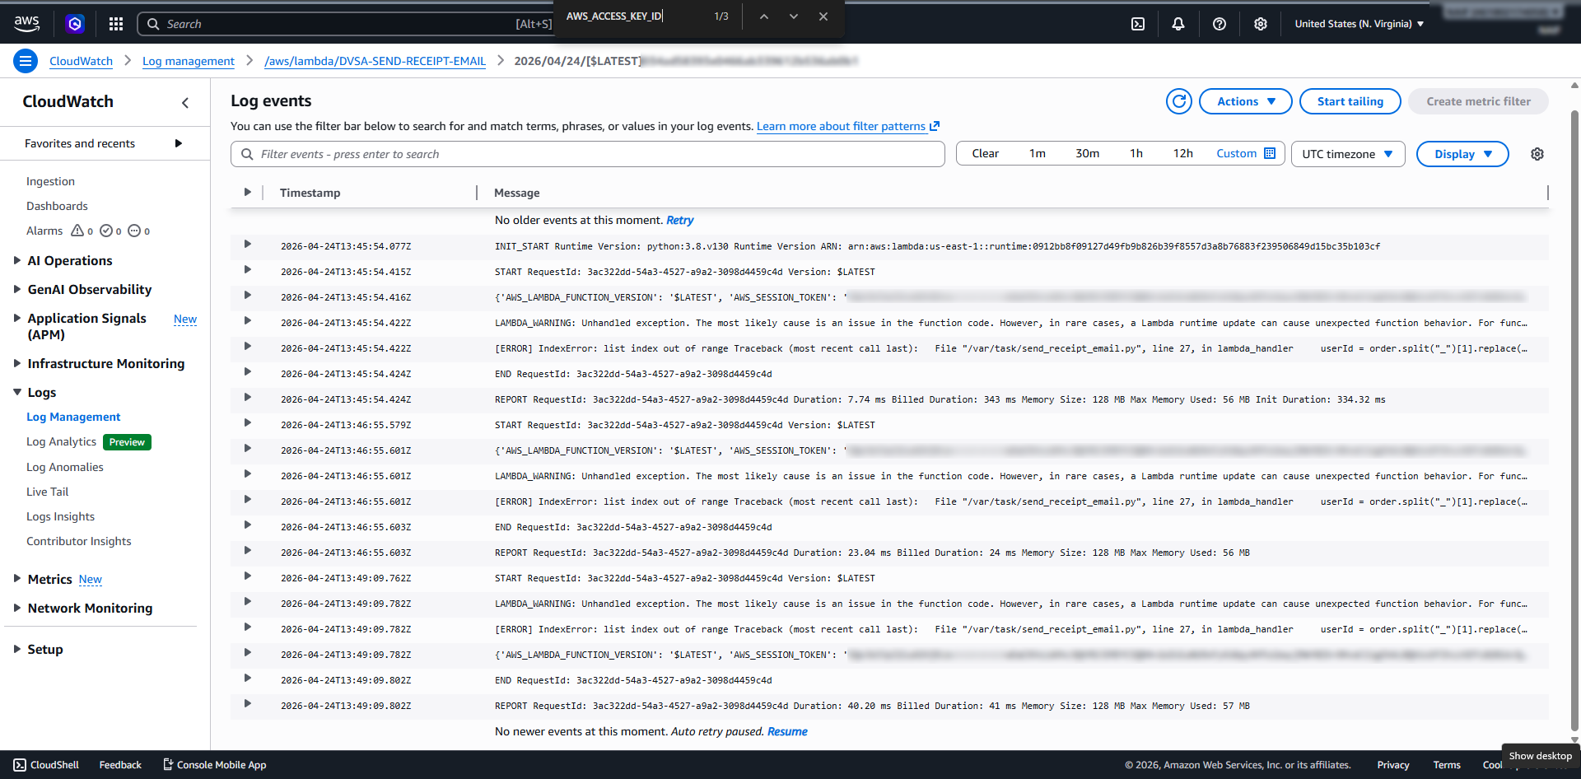
Figure 5: Screenshot #4 - Harvested Credentials
To demonstrate the full impact of the over-privileged role, the exfiltrated STS credentials (AccessKeyId, SecretKey, and SessionToken) were configured in a local CloudShell environment. By hijacking the Lambda’s identity, it was possible to perform unauthorized actions that a receipt-processing function should never be allowed to do, such as listing all other Lambda functions in the account. This confirmed the 'full chain' exploit from initial leak to account-wide infrastructure enumeration.
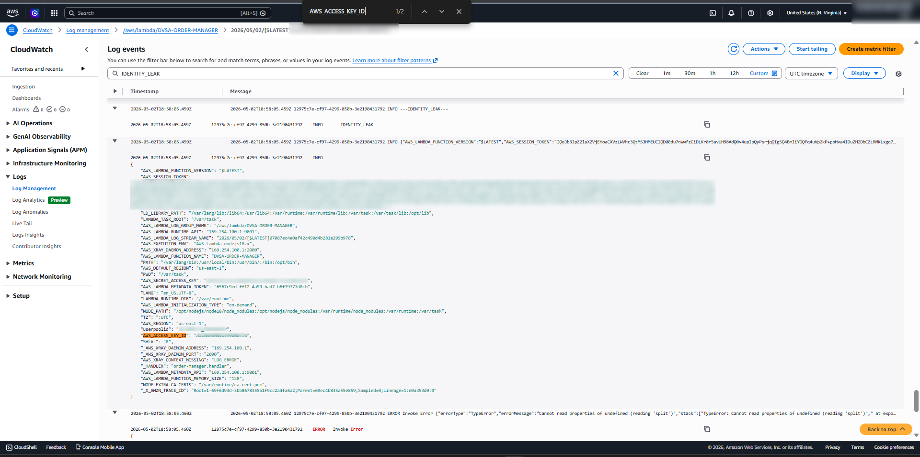
Figure 6: Exfiltration of temporary STS credentials from the vulnerable Order Manager path via the IDENTITY_LEAK payload.
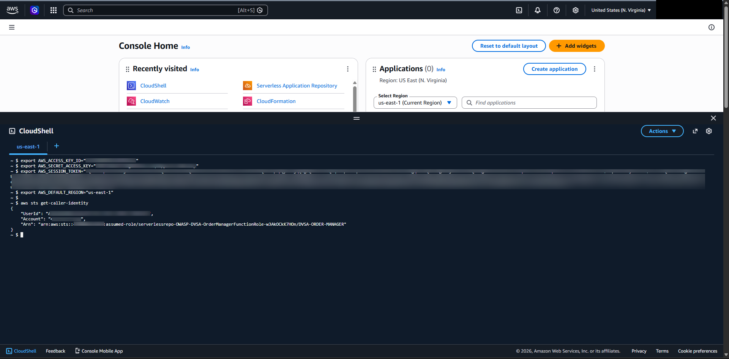
Figure 7: Verification of successful identity hijacking in CloudShell using the stolen STS session token.
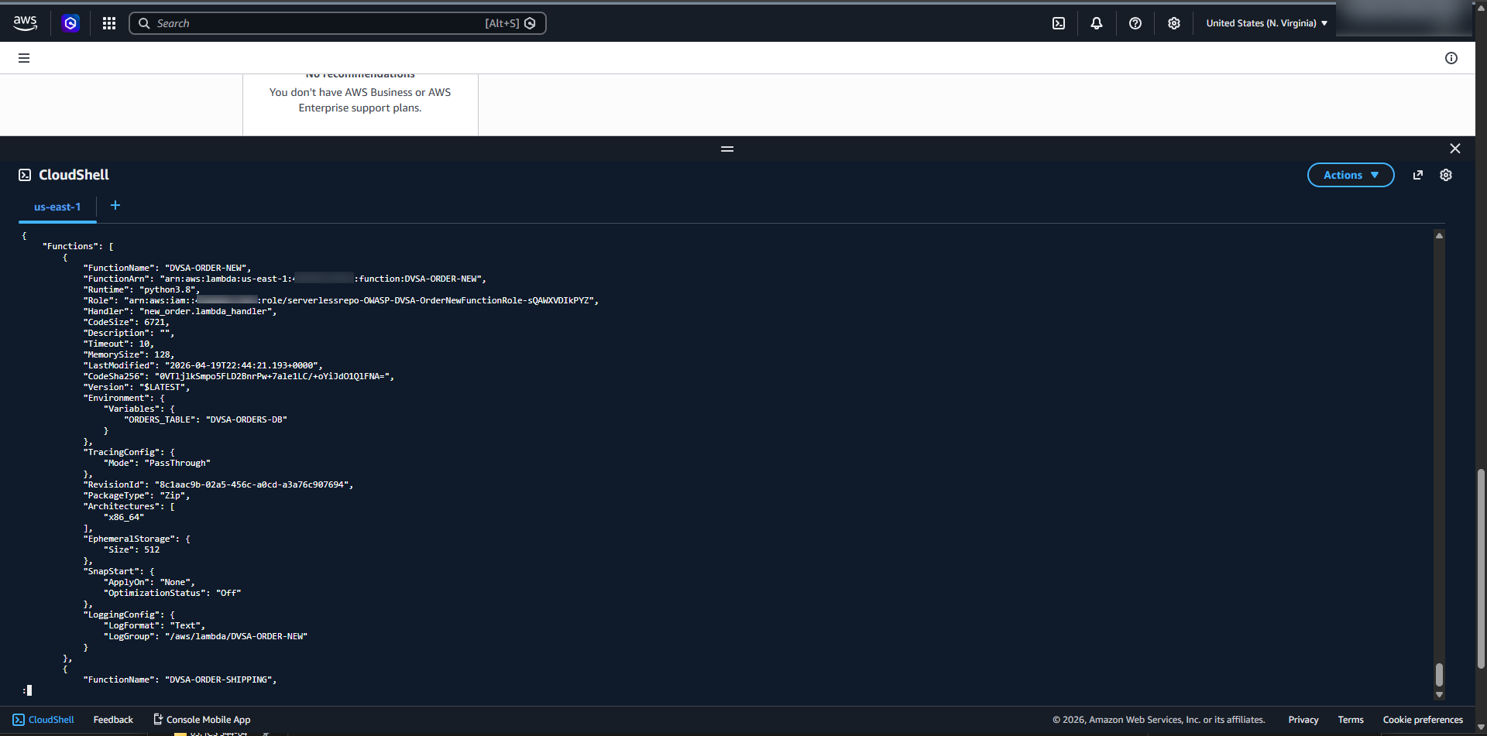
Figure 8: Proof of Over-Privilege—Using the hijacked role to list all backend infrastructure functions.

Fix Strategy / Probable Mitigation
The remediation had two main parts. First, the unsafe logging statement print(dict(os.environ)) was removed from the Lambda code to stop exposing environment variables in CloudWatch logs. Second, the execution role was reduced to least privilege by modifying SendReceiptFunctionRolePolicy2 and removing unnecessary DynamoDB actions such as scanning, querying, and broad data modification actions. After the fix, the function retained only the minimum permissions needed for its intended receipt-processing behavior.

Code / Config Changes
Two changes were applied during remediation. First, the temporary debugging statement print(dict(os.environ)) was removed from send_receipt_email.py so that runtime environment variables would no longer be exposed in CloudWatch logs. Second, the IAM policy SendReceiptFunctionRolePolicy2 was modified to reduce permissions to least privilege. Before the fix, the policy allowed broad DynamoDB actions such as Scan, Query, PutItem, DeleteItem, UpdateItem, BatchWriteItem, BatchGetItem, DescribeTable, and ConditionCheckItem. After remediation, the policy was reduced so that unnecessary DynamoDB actions were no longer allowed. This limited the function to only the permissions needed for its intended behavior.

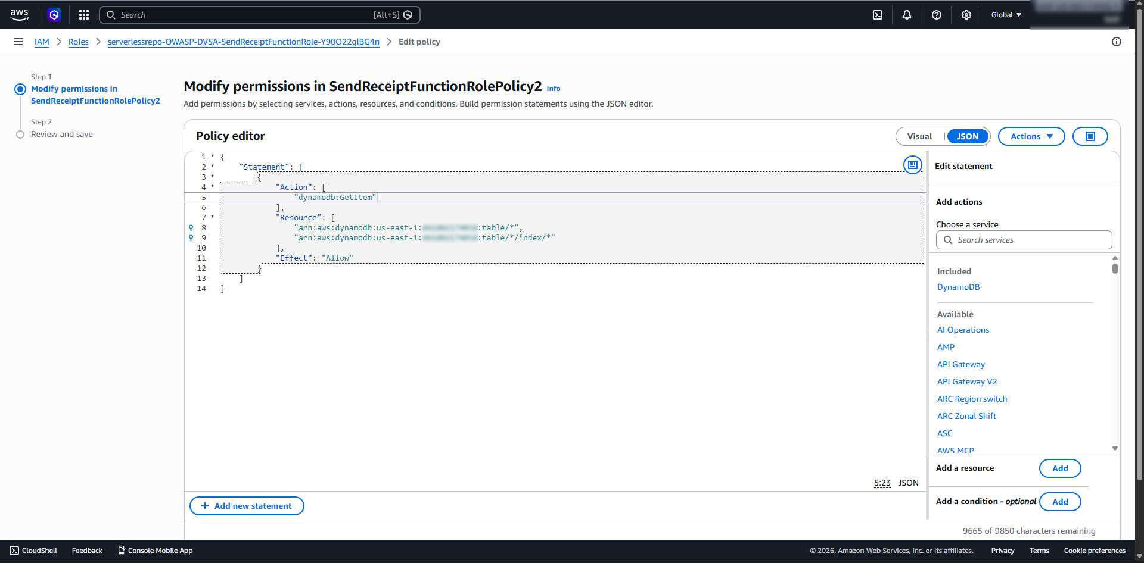
Figure 9: Screenshot #6 - Fixed Policy2 Least Privilege
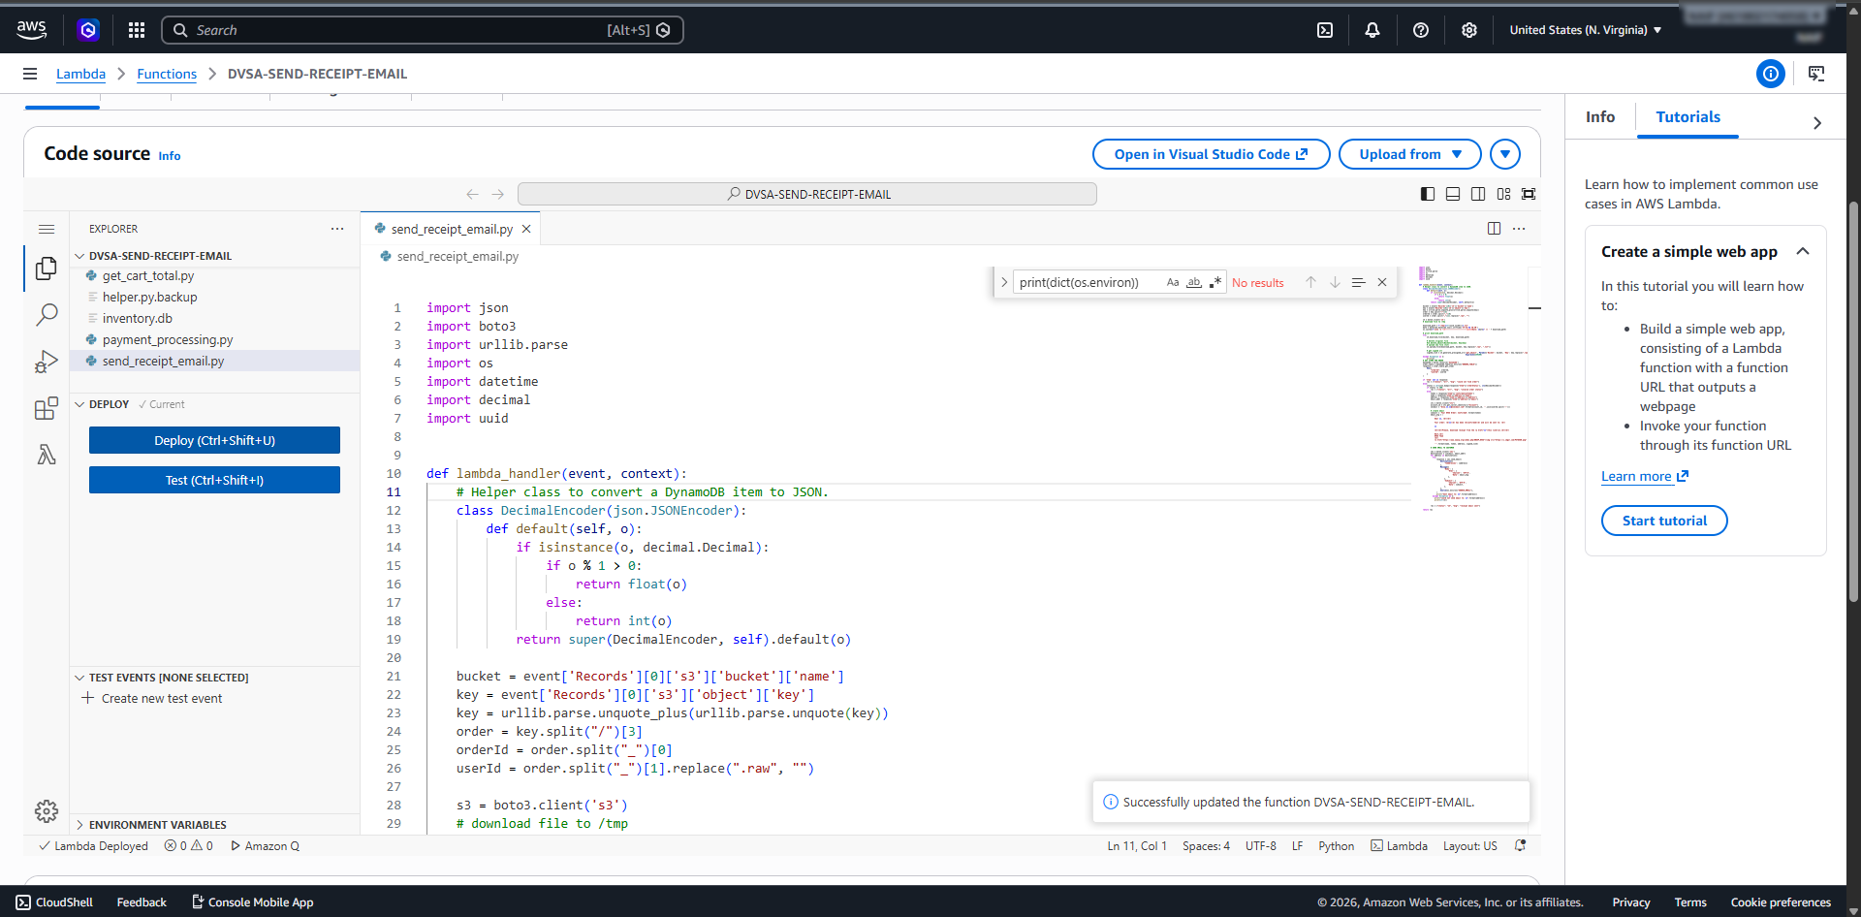
Figure 10: Screenshot #7 - Removed Credential Logging Code

Verification After Fix
After applying the fix, the function was deployed again and the same S3-trigger method was repeated. CloudWatch logs were checked to verify that sensitive values such as AWS_ACCESS_KEY_ID and AWS_SECRET_ACCESS_KEY no longer appeared in the log output. Then, IAM Policy Simulator was used to test dynamodb:Scan after the policy change, and the result showed that dynamodb:Scan was denied. This confirmed that the excessive privilege had been removed and that the sensitive logging issue was also fixed.
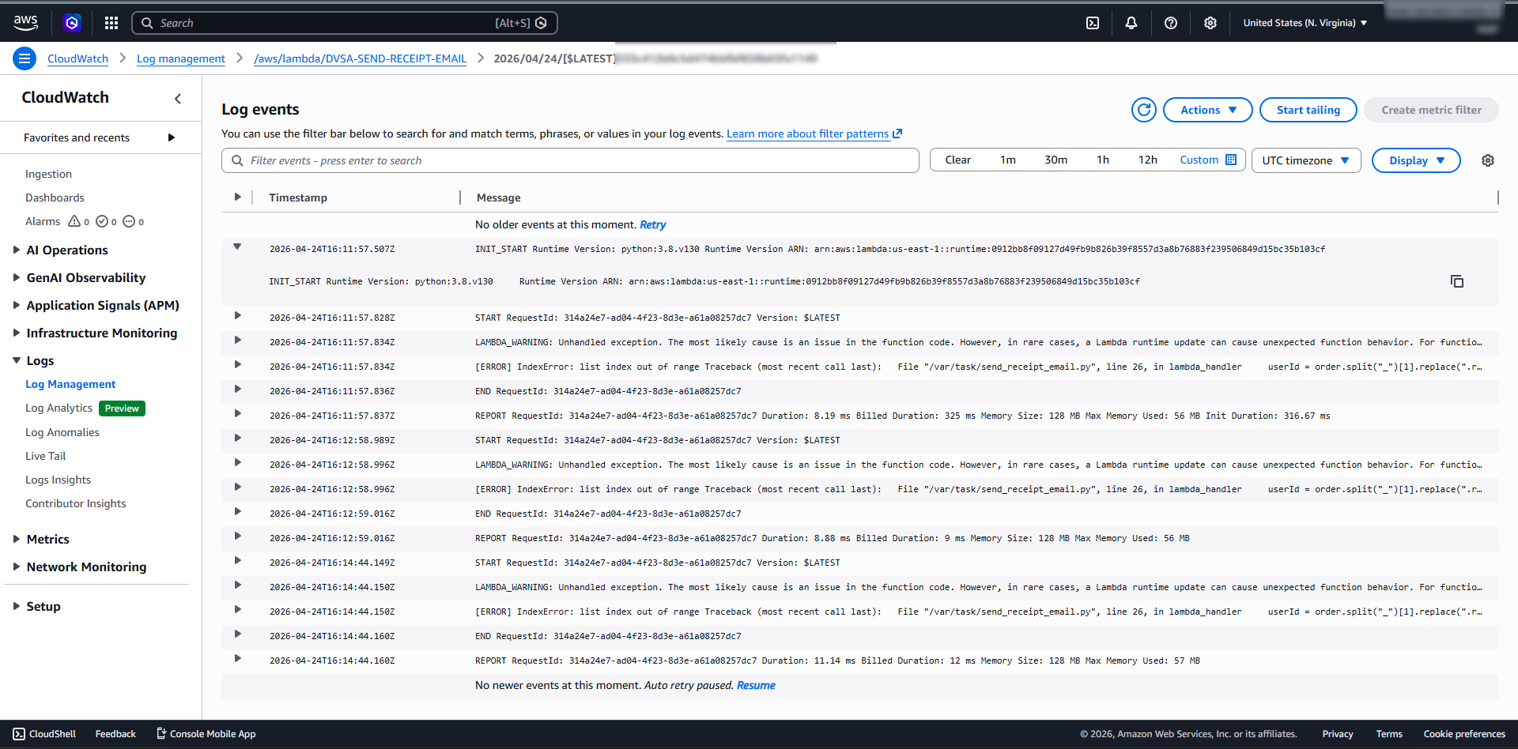
Figure 11: Screenshot #8 - Post‑Fix CloudWatch No Credential Leak
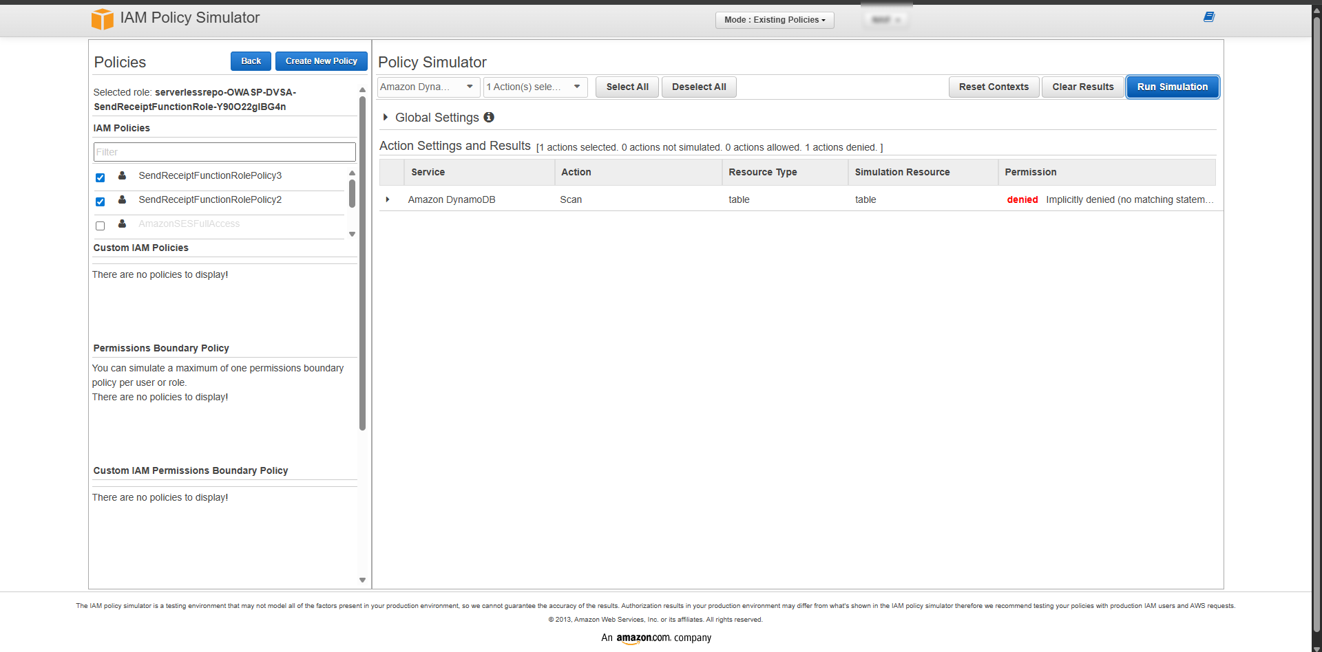
Figure 12: Screenshot #9 - IAM Simulator After Fix Denied

Structured Operation and Security Analysis

Intended Logic and Security Rule(s):
The DVSA-SEND-RECEIPT-EMAIL Lambda function is intended to process receipt-related events only. It should access only the minimum AWS resources required for receipt handling, and it should never expose runtime secrets or credentials in logs. Its execution role should follow the principle of least privilege and should not permit unrelated DynamoDB enumeration or broad backend data access.

Evidence Sources and Behavior Trace:
The analysis relied on the Lambda execution role policies, the send_receipt_email.py function code, the CloudWatch log output after the S3 trigger, and the IAM Policy Simulator results before and after the fix. The S3 upload triggered the Lambda, the function executed, and CloudWatch logs showed that sensitive environment variables were exposed when debugging output was added.

Normal vs. Exploit Behavior:
Under normal behavior, the function should process receipt events without disclosing credentials and without possessing unnecessary database permissions. Under exploit conditions, the function leaked temporary AWS credentials into CloudWatch logs, and its execution role had broader DynamoDB permissions than required, increasing the blast radius if the function were abused.

Why This Is a Security Deviation / Fix / Verification:
This is a security deviation because a receipt-processing Lambda function should not expose runtime credentials and should not have excessive database permissions unrelated to its task. The fix removed unsafe credential logging and reduced SendReceiptFunctionRolePolicy2 to least privilege. Verification showed that sensitive AWS credential fields no longer appeared in CloudWatch logs and that dynamodb:Scan was denied after the policy update.

Takeaway / Lessons Learned
This lesson shows that serverless security is not only about preventing code flaws, but also about correctly limiting IAM permissions and avoiding unsafe logging practices. Even a small debugging change can become dangerous if it exposes credentials in logs. Applying least privilege and reviewing what a function really needs are essential to reducing risk in AWS serverless applications.

